REQUEST FOR INFORMATION (RFI)
RFI # 608/2025: Acoustic absorption alternatives |  | SUBMITTED TO: NTA Metropolitan Mass Transit System Ltd.
DATE OF SUBMISSION:
SUBMITTED BY:
PROJECT: Tel Aviv Metro

BACKROUND AND PURPOSE OF THE RFI
NTA Metropolitan Mass Transit System Ltd. ("NTA") is the company responsible for the design and construction of a mass transit system for the Tel Aviv metropolis (the "Mass Transit System"). Through this Request for Information (the "RFI") NTA wishes to receive relevant information about innovative solutions, from material manufacturers which have proven experience with the production of acoustically absorptive materials and finishes for Metro network or similar applications.

This RFI is a preliminary process initiated by NTA, solely for receiving information and conducting its initial internal evaluation and consideration.

This RFI does not, in any manner whatsoever, constitute a tender, bid, offer, proposal, or request nor does it constitute an engagement, representation or warranty on behalf of NTA. Response to this request will not constitute a condition for participation in the tender, if any is subsequently issued, and no advantage will be given in the tender to those who responded to the RFI. Based on the responses to this RFI, suitable companies may be invited for further deliberations by NTA, at its sole discretion. Responses are welcome from both single suppliers and / or consortia that can provide a range of material alternatives which meet the criteria herein.

INTRODUCTION OF NTA
NTA is the governmental company responsible for the development of the Tel Aviv Metropolitan Mass Transit System, a network of light rail transit and future metro railway lines. NTA is leading an economic and cultural revolutionary transformation in the transportation sector by constructing the mass rail transit system of the Gush Dan region. The Mass Transit System is the largest and most complex transportation project in Israel.

The Mass Transit System integrates with all means of transportation, including three Light Rail Transit (LRT) lines and three Metro Lines as follows:
- The Red Line Project (RLP), that has recently commenced operating, extends from Bat Yam to Petach Tikva via Tel Aviv, Ramat Gan and Bnei Brak and is one of the most heavily used traffic corridors in the Tel Aviv Metropolitan area. It stretches, in total, over approximately 24 km, and comprises at-grade sections ( 24 stops) at both ends and a central underground section of approximately 12 km with 10 stations .
- The Purple Line. The total length of the line will stretch over approximately 27 km, with 46 stops. The line is entirely at-grade and includes bridges. At the eastern end of the line, a depot for heavy maintenance is located. Two Stops will be located on the bridges.
- The Green Line. The line connects between Rishon Le Zion at the south, Tel Aviv in the middle and Herzliya at the North. The line is 39 km long, with 4.5 km running underground. It has 62 stops, 4 of which are underground.
- The Metro System network includes 3 lines:
- The first line (M1) is 85 km long and includes two branches from the south and two from the north joining in a common section along the Ayalon-Namir corridor includes 62 stations
- The second line (M2) is 25 km long and serves the eastbound corridor from Petah Tikva to Ramat Gan, Tel Aviv and Bikat Ono includes 22 stations.
- The third line (M3) is 39 km long and connects Tel Aviv north coast to the south coast via a half-ring to the east includes 25 stations.

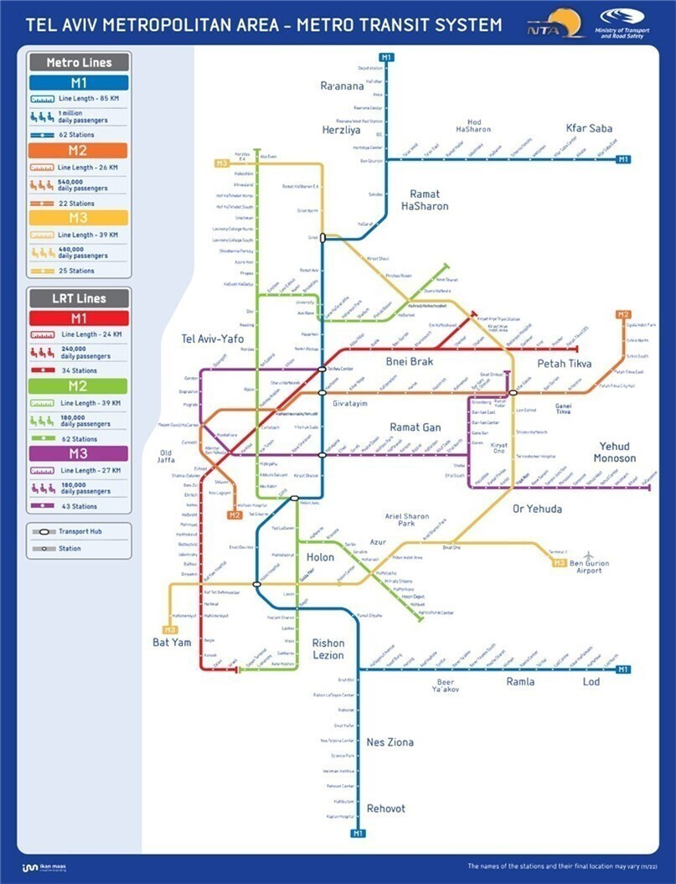

SPECIFICATIONS FOR REQUESTED SOLUTIONS
Responses to this RFI are welcome from Suppliers / Consortia which have proven experience providing solutions to control sound to:
- Improve speech intelligibility of announcements;
- Promote an acoustically calm environment.

through design of acoustic surfaces and or by use of acoustically absorbent finishes or materials that are currently at market or in use (or are developing innovative next generation solutions) that have or could have evidence to suggest it provides better performance, is more sustainable and or safer than mineral wool/glass wool and that satisfies the criteria summarized below:
- Provides a sound absorption of Class C or above, as defined by EN ISO 11654:1997.
- Has been/can be tested in accordance with EN ISO 354:2003.
- Has been/can be tested in accordance with EN ISO 10534-1:1996.
- Has been/can be tested in accordance with EN ISO 10534-2:2023.
- Requires limited/no maintenance.
- Can demonstrate fire performance tested in accordance with EN 13501 and rated A1 or equivalent.

The intention is to assess the potential benefit for use in the design, specification, construction and operation of underground metro stations.

A LIST OF DATES FOR THIS RFI
- Date of publication of the RFI - 11.11.2025
- The deadline for submission of clarification questions by the Participants - 25.11.2025
- The deadline for submission of responses to the RFI - 23.12.2025

COMMERCIAL CONFIDENTIALITY AND WAIVER OF CLAIMS
- NTA may use any information it receives during or in connection with the RFI from a Participant or any third party (the "Information") for any purpose it deems fit, including for preparing specifications, tenders or any other documents. In addition, NTA may transfer any such Information to any of its consultants or any person on its behalf. The supplier of the Information waives all claims and demands of any kind against NTA in connection with NTA's above-mentioned rights, including (but not limited to) copyrights, commercial confidentiality, privacy, etc.
- Without derogating from the above, the Participants may mark, in a clear, complete and legible manner, Information contained in the Response which is considered commercially sensitive or of a confidential nature. To the extent permitted by applicable laws, and at its sole discretion, NTA shall consider refraining from disclosing such Information (if so requested).
- The Participant declares and confirms that the provided information is free from any violations of third-party rights, including (but not limited to) copyrights, commercial confidentiality, privacy etc. The Participant shall bear full and exclusive responsibility for any claims or demands arising from such third-party rights violations subsequent to this RFI, and all related expenses will be solely borne by the Participant.

INSTRUCTIONS REGARDING THE SUBMISSION OF THE RESPONSE TO THE RFI
- Participants are free to choose the questions to respond to, based on their expertise and experience. It is not mandatory to respond to all of the questions.
- The Participants are requested to fill-in all the information on Annex A. Each question should be addressed separately.
- It is recommended to attach supporting information in a visual format such as presentations, videos, photos, brochures, etc.
- The response to the RFI shall be submitted in English. Appendices and technical specifications can be attached unlimited in scope.
- The response to the RFI must be submitted in a digital copy by the deadline for submitting responses, as specified in section 4 above, via email: Tender1@nta.co.il. The email’s subject line will state: "A response to RFI to receive relevant information about technological and design innovative solutions for PIDS (Passenger Information Display System)”.
- NTA may postpone the response submission deadline at its sole discretion. A notice to that effect shall be posted on NTA's website and shall specify the new response submission date.

EXAMINATION OF THE RESPONSE
- NTA reserves the right, at its sole discretion, to contact, as necessary, all or some of the Participants with requests for information and clarifications, for presentations and demonstrations, for visits to the Participants' sites and the sites of their clients, etc.
- As part of the response examination process, NTA reserves the right to invite any Participant to present the solution proposed by it to a professional team on its behalf at a location and at a time determined by NTA.
- As part of the response examination process, NTA reserves the right, at its sole discretion, to invite all or some of the Participants to launch a pilot project.

QUESTIONS AND CLARIFICATION REQUESTS
- Clarification questions regarding this RFI must be submitted only in writing, via e-mail to NTA's email , as specified in section 6(5) above. The questions must be submitted no later than the deadline for clarification questions as detailed in section 5 above.
- NTA reserves the right to conduct one or more rounds of clarification questions at its sole discretion.
- The clarification questions will be submitted in English, in the following format:

Number of the section in the RFI | Question
- Answers to the clarification questions will be posted on NTA's website.
- Clarification answers will be worded in a way that does not reveal the identity of the inquirer.

RESERVATIONS AND NTA'S DISCRETIONS
- NTA may publish a new RFI, an invitation to pre-qualify, tender proceedings and/or any other proceedings with respect to the Project or any part thereof and/or with respect to any other project whatsoever, in any manner which it will deem appropriate. Without derogating from the above, NTA may pursue any engagement based on the information submitted in this RFI, whether through the conduct of a bid or a tender, or without conducting such proceedings, as NTA deems fit.
- NTA may request additional information (in writing or otherwise) as it deems necessary, request to visit sites or facilities constructed or operated by the Participant or carry out professional inquiries regarding any Participant (including by way of contacting third parties(.
- The Participants shall not be entitled to any payment for the information provided by them pursuant to this RFI. All expenses incurred by a Participant or anyone on its behalf shall be borne solely by the Participant. Participants shall not be entitled to any reimbursement or compensation for expenses in connection with their participation in this RFI.
- NTA shall not be responsible or liable towards a Participant or anyone on its behalf in connection with this RFI, including in connection with information provided by or to NTA pursuant to or in connection with this RFI.
- NTA may amend, withdraw or cancel this RFI, at any time and without providing reasons or justifications for doing so.
- This RFI is subject to the law of the State of Israel, including the Mandatory Tenders Regulations, 5753-1993 and the obligation to disclose information in accordance with Section 14A thereof.

CONTACT PERSON ON BEHALF OF NTA
The contact person on behalf of NTA regarding this RFI is Orly Cohen, email: Tender1@nta.co.il.

ANNEX A - RESPONSE TO THE RFI
General:
- It is not mandatory to respond to all of the questions.
- Additional information should be attached to this Appendix.
- It is recommended to attach supporting information in a visual format such as presentations, videos, photos, brochures etc.

- Information about the Participant:
Supporting documents for questions 1-2 below shall be attached in a separate file captioned "Appendix 1".

1. General details regarding the company submitting the response (the "Participant"):
Participant's name:
(Name of company or individual submitting the response)
Classification of the Participant: (corporation, association, authorized dealer, independent consultant, etc.)
I.D number/Company Registration Number:
Contact Person:
(Full name, position)
Address:
Phone no.:
E-mail:
2. Details about the Participant's knowledge and area of expertise and the relevance of the Participant’s experience to the Project.
- Information about the proposed “Solution/s”:
* Documents supporting answers to questions 3 + 4 will be attached in a separate file captioned "Appendix 2".
P.N. Responses to this RFI are welcome from Suppliers / Consortia with relevant experience in providing absorptive finishes for metro or other complex transportation projects, or who demonstrate and provide relevant innovative and applicable capabilities.
- Acoustically absorbent surfaces and or finishes
  - What range of acoustically absorbent surfaces and or finishes do you provide?
  - What is the measured acoustic performance of said surface/finishes?
  - Please provide test certificates for this acoustic performance in line with EN ISO 354:2003?
  - Please provide test certificates for this acoustic performance in line with EN ISO 10534-1:1996?
  - Please provide test certificates for this acoustic performance in line with EN ISO 10534-2:2023?
  - What safety, maintenance, and durability standards are met by your products? Please indicate compliance with environmental and durability standards including heat, humidity, corrosion, dust, vandalism, and EMI
  - What are the key advantages of your solution/product over competing solutions/products?
  - How is your product more sustainable than mineral wool?
  - Please provide calculations/evidence of Embodied Carbon of your product?
  - Please provide calculations/evidence of Whole Life Carbon of your product?
  - Please provide any evidence of consideration toward circular economy of your product?
  - Does your surface/product provide any opportunity for reducing or eliminating the quantity of material necessary to provide acoustic absorption and control reverberation (pertaining to Reduce, one of the R’s in the hierarchy of sustainability)?
  - Does your product provide any opportunity for reuse after or during the project life (pertaining to Reuse, one of the R’s in the hierarchy of sustainability)?
  - Does your product provide any opportunity for repair during the project life (pertaining to Repair, one of the R’s in the hierarchy of sustainability)?
  - Does your product provide any opportunity for recycling after the project life (pertaining to Recycle, one of the R’s in the hierarchy of sustainability)?
  - Material which requires less maintenance, repair, and replacement will ultimately be more sustainable. What evidence can you provide of these qualities in the use case of high-traffic public spaces such as train stations or equivalent?

- Where can your system be seen/experienced in use?
- Can your system be piloted or tested before a full-scale deployment, and what are the evaluation criteria?
C. Information regarding maintenance of the proposed Solution:
* Documents supporting answers to question 9, will be attached in a separate file captioned "Appendix 3".
- For each unique solution proposed: What maintenance, support, and upgrade services do you offer? What maintenance and durability standards are met by your products?
Integration:
  - What regulatory approvals, standards, or certification processes are required for implementing your solution in Israel or the European Union (if applicable)?
  - Do you have a customer service and technical support presence in Israel? If not, how is support provided (location of service center, hours of operation, SLA, spare parts availability, etc.)?
  - Do you provide training programs and documentation for installers and maintenance teams as part of the deployment or handover process?

- Future-readiness
  - How is your solution prepared for future changes, including regulatory adaptations?
  - Do you have a roadmap for the coming years?
D. Additional relevant information about the proposed technological Solution/s or other solutions/functionalities relevant to the scope of the project.
* Documents supporting further information will be attached in a separate file captioned "Appendix 4".

RESPONSE BY: [NAME, TITLE, COMPANY] |  | DATE:
ATTACHMENTS:

