REQUEST FOR INFORMATION (RFI)
RFI #: 373/2025 |  | SUBMITTED TO MAIL:  TIME:
DATE OF SUBMISSION : |  | SUBMITTED TO MAIL:  TIME:
PROJECT: |  | SUBMITTED BY: [NAME/TITLE COMPANY]

BACKROUND AND PURPOSE OF THE RFI
NTA Metropolitan Mass Transit System Ltd. ("NTA") is the company responsible for the design and construction of a mass transit system for the Tel Aviv metropolis (the "Mass Transit System"). Through this Request for Information (the "RFI") NTA wishes to receive relevant information about technological and innovative solutions, from technology providers which have proven experience with seamless ticketing system design and production for Metro network or similar applications. Innovative solution for seamless ticketing could be a system where users can buy, access, and validate tickets with little to no friction—no long queues, no confusing apps, no paper waste. It’s all about convenience, speed, and a smooth experience from purchase to entry.

This RFI is a preliminary process initiated by NTA, solely for receiving information and conducting its initial internal evaluation and consideration. This RFI does not, in any manner whatsoever, constitute a tender, bid, offer, proposal, or request nor does it constitute an engagement, representation or warranty on behalf of NTA. Response to this request will not constitute a condition for participation in any subsequent tender and no advantage will be given in the tender to those who responded to the RFI. Based on the responses to this RFI, suitable companies may be invited for further deliberations by NTA, at its sole discretion. Responses are welcome from both single suppliers and / or consortia that can provide a range of seamless ticketing solutions.

INTRODUCTION OF NTA
NTA is the governmental company responsible for the development of the Tel Aviv Metropolitan Mass Transit System, a network of light rail transit and future metro railway lines. NTA is leading an economic and cultural revolutionary transformation in the transportation sector by constructing the mass rail transit system of the Gush Dan region. The Mass Transit System is the largest and most complex transportation project in Israel.

The Mass Transit System integrates with all means of transportation, including three Light Rail Transit (LRT) lines and three Metro Lines as follows:
- The Red Line Project (RLP), that has recently commenced operating, extends from Bat Yam to Petach Tikva via Tel Aviv, Ramat Gan and Bnei Brak and is one of the most heavily used traffic corridors in the Tel Aviv Metropolitan area. It stretches, in total, over approximately 24 km, and comprises at-grade sections at both ends and a central underground section of approximately 12 km.
- The Purple Line. The total length of the line will stretch over approximately 27 km, with 46 stops. The line is entirely at-grade and includes bridges. At the eastern end of the line, a depot for heavy maintenance is located. Two Stops will be located on the bridges.
- The Green Line. The line connects between Rishon Le Zion at the south, Tel Aviv in the middle and Herzliya at the North. The line is 39 km long, with 4.5 km running underground. It has 62 stops, 4 of which are underground.
- The Metro System network includes 3 lines:

- The first line (M1) is 85 km long and includes two branches from the south and two from the north joining in a common section along the Ayalon-Namir corridor
- The second line (M2) is 25 km long and serves the eastbound corridor from Petah Tikva to Ramat Gan, Tel Aviv and Bikat Ono.
The third line (M3) is 32 km long and connects Tel Aviv north coast to the south coast via a half-ring to the east.

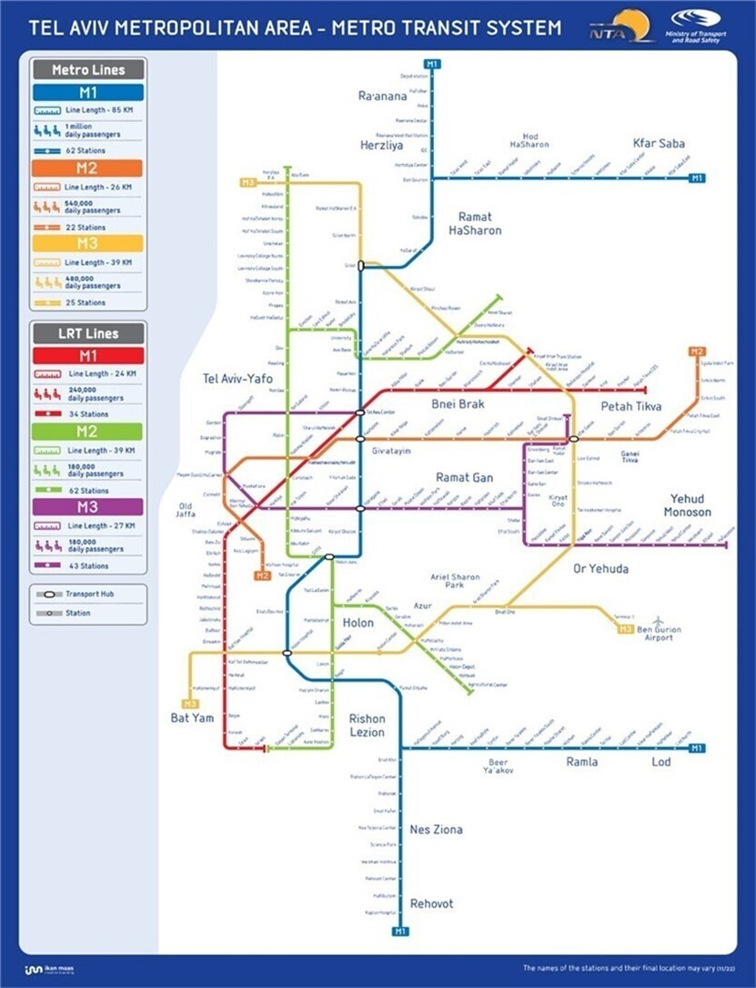

The ticketing eco system in Israel is regulated by MoT and interoperability is national. The national smartcard Rav-Kav is interoperable. ABT mobile applications are common and interoperable nationally. EMV as a fare media implementation is in its early stages.

SPECIFICATIONS FOR REQUESTED SOLUTIONS
Responses to this RFI are welcome from Suppliers / Consortia, which have proven experience with seamless ticketing technology for similar projects and are developing innovative solutions Metro Networks that satisfies the criteria summarized below.
- The solution must support seamless, gateless hand-free validation to enable free passenger flow (XiXo e.g. any combination of check-in or be-in, check out or be-out).
- It should be designed for high-capacity urban metro environments with peak-hour congestion.
- Validation must be real-time, with minimal latency and high reliability.
- Gateless validation must include passive detection (e.g., Bluetooth, UWB, facial recognition, etc.) and active validation in both directions – paid area entry and exit and\or boarding\exiting from the train (e.g., tap-in/out).
- End-to-end encryption and secure authentication protocols are required.
- System must support fraud detection and fare evasion prevention mechanisms.
- Should support real-time data exchange with central control systems and third-party apps. The sensors\readers should be able to connect directly with ABT mobile applications 3rd party operators (already implemented locally) and\or with NTA AFC back-office.
- A complementary solution for non-ABT apps passengers may be proposed such as a long-range RFID cards or similar technology.
- It should be scalable to support millions of daily transactions and hundreds of stations.
- It must be fully accessible to people with disabilities.

A LIST OF DATES FOR THIS RFI
- Date of publication of the RFI – 9.7.2025
- The deadline for submission of clarification questions by the Participants – 23.7.2025
- The deadline for submission of responses to the RFI – 1.9.2025

COMMERCIAL CONFIDENTIALITY AND WAIVER OF CLAIMS
- NTA may use any information it receives during or in connection with the RFI from a Participant or any third party (the "Information") for any purpose it deems fit, including for preparing specifications, tenders or any other documents. In addition, NTA may transfer any such Information to any of its consultants or any person on its behalf. The supplier of the Information waives all claims and demands of any kind against NTA in connection with NTA's above-mentioned rights, including (but not limited to) copyrights, commercial confidentiality, privacy, etc.
- Without derogating from the above, the Participants may mark, in a clear, complete and legible manner, Information contained in the Response which is considered commercially sensitive or of a confidential nature. To the extent permitted by applicable laws, and at its sole discretion, NTA shall consider refraining from disclosing such Information (if so requested).
- The Participant declares and confirms that the information provided is free from any violations of third-party rights, including (but not limited to) copyrights, commercial confidentiality, privacy etc. The Participant shall bear full and exclusive responsibility for any claims or demands arising from such third-party rights violations subsequent to this RFI, and all related expenses will be solely borne by the Participant.

INSTRUCTIONS REGARDING THE SUBMISSION OF THE RESPONSE TO THE RFI
- Participants are free to choose the questions to respond to, based on their expertise and experience. It is not mandatory to respond to all of the questions.
- The Participants are requested to fill-in all the information on Annex A. Each question should be addressed separately.
- It is recommended to attach supporting information in a visual format such as presentations, videos, photos, brochures, etc.
- The response to the RFI shall be submitted in English. Appendices and technical specifications can be attached unlimited in scope.
- The response to the RFI must be submitted in a digital copy by the deadline for submitting responses, as specified in section 5 above, via email: Tender2@nta.co.il. The email’s subject line will state: "A response to RFI to receive relevant information about technological and design innovative solutions for seamless ticketing system design and production”.
- NTA may postpone the response submission deadline at its sole discretion. A notice to that effect shall be posted on NTA's website. The notice shall specify the new response submission date.

EXAMINATION OF THE RESPONSE
- NTA reserves the right, at its sole discretion, to contact, as necessary, all or some of the Participants with requests for information and clarifications, for presentations and demonstrations, for visits to the Participants' sites and the sites of their clients, etc.
- As part of the response examination process, NTA reserves the right to invite any Participant to present the solution proposed by it to a professional team on its behalf at a location and at a time determined by NTA.
- As part of the response examination process, NTA reserves the right, at its sole discretion, to invite all or some of the Participants to launch a pilot project.

QUESTIONS AND CLARIFICATION REQUESTS
- Clarification questions regarding this RFI must be submitted only in writing, via e-mail to NTA's contact person, as specified in section 10 below. The questions must be submitted no later than the deadline for clarification questions as detailed in section 5 above.
- The Participant must verify that their questions were received by the contact person, as specified in section 10 below, by phone.
- NTA reserves the right to conduct one or more rounds of clarification questions at its sole discretion.
- The clarification questions will be submitted in English, in the following format:

Number of the section in the RFI | Question

- Answers to the clarification questions will be posted on NTA's website.
- Clarification answers will be worded in a way that does not reveal the identity of the inquirer.

RESERVATIONS AND NTA'S DISCRETIONS
- NTA may publish a new Request for Information, an invitation to pre-qualify, tender proceedings and/or any other proceedings with respect to the Project or any part thereof and/or with respect to any other project whatsoever, in any manner which it will deem appropriate. Without derogating from the above, NTA may pursue any engagement based on the information submitted in this RFI, whether through the conduct of a bid or a tender, or without conducting such proceedings, as NTA deems fit.
- NTA may request additional information (in writing or otherwise) as it deems necessary, request to visit sites or facilities constructed or operated by the Participant or carry out professional inquiries regarding any Participant (including by way of contacting third parties(.
- The Participants shall not be entitled to any payment for the information provided by them pursuant to this RFI. All expenses incurred by a Participant or anyone on its behalf shall be borne solely by the Participant. Participants shall not be entitled to any reimbursement or compensation for expenses in connection to their participation in this RFI.
- NTA shall not be responsible or liable towards a Participant or anyone on its behalf in connection with this RFI, including in connection with information provided by or to NTA pursuant to or in connection with this RFI.
- NTA may amend, withdraw or cancel this RFI, at any time and without providing reasons or justifications for doing so.
- This RFI is subject to the law of the State of Israel, including the Mandatory Tenders Regulations, 5753-1993 and the obligation to disclose information in accordance with Section 14A thereof.

CONTACT PERSON ON BEHALF OF NTA
The contact person on behalf of NTA regarding this RFI is Sivan Cohen email Tender2@nta.co.il.

ANNEX A - RESPONSE TO THE RFI
General:
- This Appendix must be Digital.
- Additional information should be attached to the relevant Appendix.
- It is recommended to attach supporting information in a visual format such as presentations, videos, photos, brochures etc.

- Information about the Participant:
Supporting documents for questions 1-2 below shall be attached in a separate file captioned "Appendix 1".

1. General details regarding the company submitting the response (the "Participant"):
Participant's name:
(Name of company submitting the response)
Classification of the Participant: (corporation, association, etc.)
I.D number/Company Registration Number:
Contact Person:
(Full name, position)
Address:
Phone no.:
E-mail:
2. Details about the Participant's knowledge and area of expertise and the relevance of the Participant’s experience to the Project, if any.
- Information about the proposed “Solution/s”:
* Documents supporting answers to questions 3-7, complying where possible with the “Specifications” listed in section 4, will be attached in a separate file captioned "Appendix 2".

P.N. Responses are welcome from big Suppliers/Consortia that have experience with Ticketing System which has been implemented in similar Metro/Transportation projects embracing all main project lifecycle and comply with the “Specifications” specified in section 3.
- Solution overview
  - Please describe your seamless ride gateless solution architecture (technology, communication protocol, hardware, beacons, sensors, software other).
  - What technologies are used for passenger identification and validation (e.g., Bluetooth, , facial recognition, GPS , Wi-Fi, other)?
  - Is your solution modular and scalable to accommodate future expansions or upgrades?
  - Does your solution require hardware installation of beacons\sensors\readers\cameras or other devices?
  - Does your solution fit for installation in underground stations and in at-grade open-air stations?
How does your solution identify an entry of a to the paid area (check-in) and exit from station (check-out)? How does the solution handle passenger "u-turns" (i.e., passengers entering and exiting the stations' paid area)?

Does your solution support installation of devices on-board and identification of boarding and alighting stations?
Do you recommend installing devices in Stations and on-board?
does your solution record the route of the passenger or specific points along the route between the boarding and alighting?
Does the technology support/can it support Light Rail At Grade stops, Israel Railways stations and bus stops?
  - Are you interested in pilot projects with your solution in the existing Light Rail network of Tel Aviv?
- Seamless and Gateless Ticketing Capabilities
  - How does your system ensure fare validation without physical gates?
  - What methods are used to detect fare evasion in a gateless environment?
  - What is the accuracy of the solution?
  - What is the minimal and maximal distance\range for entry\exit identification?
  - What are the limitations of the solution?
  - How do you ensure continuity of service?
  - Does your solution is based on software installed on the edge devices? how is software upgrades are distributed? Backed up?
  - Based on your experience, how does your gateless solution coexist with legacy solutions such as gates and validators? Are there special requirements for the layout of stations?
- Data, Security, and Privacy
  - How is passenger data secured and anonymized?
  - What standards and certifications do your system comply with (e.g., GDPR, ISO 27001)?
  - How is real-time data collected and used for operational insights?
- Integration and Interoperability
How does your system integrate with existing or planned Israeli ticketing eco-system?
  - ?
  - What APIs or SDKs are available for third-party integration. E.g. easy integration of sensors\readers directly 3rd party ABT apps?
  - Do you provide mobile app software that could be integrated with the local ABT apps already implemented nationally?
- Innovation and Future Readiness
  - What innovations are you currently developing or piloting (e.g., AI-based fare enforcement,)?
  - How does your solution adapt to future mobility trends?
C. Information regarding maintenance of the proposed Solution:
* Documents supporting answers to question 8, will be attached in a separate file captioned "Appendix 3".
- Operations and Maintenance
  - What are your system’s uptime and reliability metrics?
  - What support and maintenance services do you offer?
  - What are the typical lifecycle costs (CAPEX and OPEX)?
- Proposed solution experience and references of projects and pilots.
* Documents supporting further information will be attached in a separate file captioned "Appendix 4".
E. Additional relevant information about the proposed technological Solution/s or other solutions/functionalities relevant to the scope of the project.
* Documents supporting further information will be attached in a separate file captioned "Appendix 5".

RESPONSE BY: [NAME, TITLE, COMPANY]: DATE:

ATTACHMENTS:

