REQUEST FOR INFORMATION (RFI)
RFI #: 149/2025 |  | SUBMITTED TO MAIL:  TIME:
DATE OF SUBMISSION : |  | SUBMITTED TO MAIL:  TIME:
PROJECT: |  | SUBMITTED BY: [NAME/TITLE COMPANY]

BACKROUND AND PURPOSE OF THE RFI
NTA Metropolitan Mass Transit System Ltd. ("NTA") is the company responsible for the design and construction of a mass transit system for the Tel Aviv metropolis (the "Mass Transit System"). Through this Request for Information (the "RFI") NTA wishes to receive relevant information about innovative solutions for future-ready Rolling Stock, including energy efficiency, optimized performance, material, maintenance and more, from suppliers which have proven experience with rolling stock design and production for Metro systems. This RFI is a preliminary process initiated by NTA, solely for receiving information and conducting its initial internal evaluation and consideration. This RFI does not, in any manner whatsoever, constitute a tender, bid, offer, proposal, or request nor does it constitute an engagement, representation or warranty on behalf of NTA. Response to this request will not constitute a condition for participation in any subsequent tender, if issued, and no advantage will be given in the tender to those who responded to the RFI. Based on the responses to this RFI, suitable companies may be invited for further deliberations by NTA, at its sole discretion. Responses are welcome from both single suppliers and / or consortia that can provide innovative rolling stock designs.

INTRODUCTION OF NTA
NTA is the governmental company responsible for the development of the Tel Aviv Metropolitan Mass Transit System, a network of light rail transit and future metro railway lines. NTA is leading an economic and cultural revolutionary transformation in the transportation sector by constructing the mass rail transit system of the Gush Dan region. The Mass Transit System is the largest and most complex transportation project in Israel.
The Mass Transit System integrates with all means of transportation, including three Light Rail Transit (LRT) lines and three Metro Lines as follows:
- The Red Line Project (RLP), that has recently commenced operating, extends from Bat Yam to Petach Tikva via Tel Aviv, Ramat Gan and Bnei Brak and is one of the most heavily used traffic corridors in the Tel Aviv Metropolitan area. It stretches, in total, over approximately 24 km, and comprises at-grade sections at both ends and a central underground section of approximately 12 km.
- The Purple Line. The total length of the line will stretch over approximately 27 km, with 46 stops. The line is entirely at-grade and includes bridges. At the eastern end of the line, a depot for heavy maintenance is located. Two Stops will be located on the bridges.
- The Green Line. The line connects between Rishon Le Zion at the south, Tel Aviv in the middle and Herzliya at the North. The line is 39 km long, with 4.5 km running underground. It has 62 stops, 4 of which are underground.
- The Metro System network includes 3 lines:
- The first line (M1) is 85 km long and includes two branches from the south and two from the north joining in a common section along the Ayalon-Namir corridor.
- The second line (M2) is 25 km long and serves the eastbound corridor from Petah Tikva to Ramat Gan, Tel Aviv and Bikat Ono.
The third line (M3) is 32 km long and connects Tel Aviv north coast to the south coast via a half-ring to the east.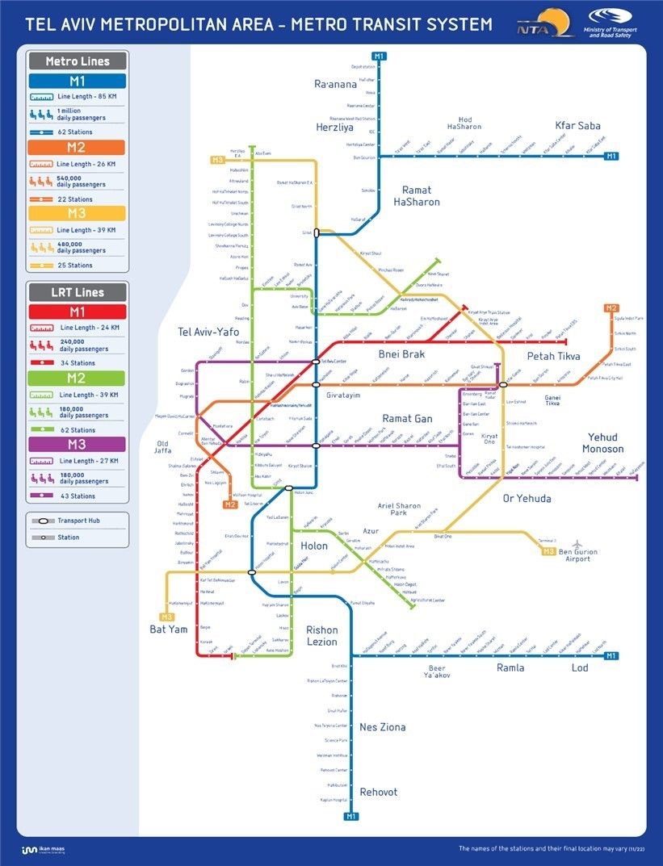

SPECIFICATIONS FOR REQUESTED SOLUTIONS
Responses to this RFI are welcome from Suppliers / Consortia which have proven experience with Rolling Stock design and manufacturing for similar projects and are developing innovative solutions for the next generation of Rolling Stocks that satisfies the criteria summarized below. In case the proposed solution(s) does not confirm to a certain requirement from the list below, the Suppliers / Consortia are requested to indicate this non-conformity.
- The Train power supply voltage system shall be 1500V dc.
- The operating height of the pantograph shall be coordinated with the ROCS as well as FOCS.
- The signaling system is GoA4, hence the Rolling Stock needs to be compliant with the grade of automation of the signaling system.
- The Trains shall be designed for the nominal track gauge of 1.435 mm.
- The Train design speed shall be 90 km/h and the operating speed shall be 80 km/h.
- The Train design shall Limit the Longitudinal jerk to 0.75 m/s3.
- The Train Electro-dynamic brake fade-out shall not occur above 3 km/h.
- The maximum acceleration shall be limited to 1.3 m/s² at an adhesion limit (motoring) of 18%.
- The maximum service brake deceleration shall be limited to 1.2 m/s².
- The maximum emergency brake deceleration shall be limited to 1.3 m/s².
- The Train design shall be able to accommodate minimal track radius of 100 m in Depot and 250 m on the line. The Rolling Stock design shall be capable of running normally under all operational conditions at the maximum gradient.
- All Trains shall be bi-directional with doors on both sides.
- The Train design shall comply with the International and Local applicable codes & standards for Electromagnetic Interference & Compatibility (EMI/EMC).
- The Train design shall ensure that the Noise levels and measuring are in accordance with compliance stated in ISO 3095 and ISO 3381.
- Each Trains shall ensure passenger running comfort according to EN 12299.
- Trains shall be equipped, with an onboard derailment detector system with at least SIL level 3.
- The frame design shall result from finite element analysis (FEA) and validated by means of specific structural tests.
- The minimum transportation capacities of the Rolling Stock of the lines shall consider 4 passengers per square meter and 20% comfort ratio.
- The car body shall be designed and validated in accordance to UIC 566/ EN 12663 Category P-III and EN 15227.
- The bogie system shall be of proven design and technology in compliance with international standards.
- Bogie frame service life shall be over 30 years.

A LIST OF DATES FOR THIS RFI
- Date of publication of the RFI – 23/3/2025
- The deadline for submission of clarification questions by the Participants – 20/4/2025 at 13:00.
- The deadline for submission of responses to the RFI – 22/5/2025 at 13:00.

COMMERCIAL CONFIDENTIALITY AND WAIVER OF CLAIMS
- NTA may use any information it receives during or in connection with the RFI from a Participant or any third party (the "Information") for any purpose it deems fit, including for preparing specifications, tenders or any other documents. In addition, NTA may transfer any such Information to any of its consultants or any person on its behalf. The supplier of the Information waives all claims and demands of any kind against NTA in connection with NTA's above-mentioned rights, including (but not limited to) copyrights, commercial confidentiality, privacy, etc.
- Without derogating from the above, the Participants may mark, in a clear, complete and legible manner, Information contained in the Response which is considered commercially sensitive or of a confidential nature. To the extent permitted by applicable laws, and at its sole discretion, NTA shall consider refraining from disclosing such Information (if so requested).
- The Participant declares and confirms that the provided information is free from any violations of third-party rights, including (but not limited to) copyrights, commercial confidentiality, privacy etc. The Participant shall bear full and exclusive responsibility for any claims or demands arising from such third-party rights violations subsequent to this RFI, and all related expenses will be solely borne by the Participant.

INSTRUCTIONS REGARDING THE SUBMISSION OF THE RESPONSE TO THE RFI
- Participants are free to choose the questions to respond to, based on their expertise and experience, it is not mandatory to respond to all of the questions.
- The Participants are requested to fill-in all the information on Annex A. Each question should be addressed separately.
- It is recommended to attach supporting information in a visual format such as presentations, videos, photos, brochures, etc.
- The response to the RFI shall be submitted in English. Appendices and technical specifications can be attached unlimited in scope.
- The response to the RFI must be submitted in a digital copy by the deadline for submitting responses, as specified in section 4 above, via email: Tender2@nta.co.il. The email’s subject line will state: "A response to RFI for innovative rolling stock solutions ".
- NTA may postpone the response submission deadline at its sole discretion. A notice to that effect shall be posted on NTA's website, and shall specify the new response submission date.

EXAMINATION OF THE RESPONSE
- NTA reserves the right, at its sole discretion, to contact, as necessary, all or some of the Participants with requests for information and clarifications, for presentations and demonstrations, for visits to the Participants' sites and the sites of their clients, etc.
- As part of the response examination process, NTA reserves the right to invite any Participant to present the solution proposed by it to a professional team on its behalf at a location and at a time determined by NTA.
- As part of the response examination process, NTA reserves the right, at its sole discretion, to invite all or some of the Participants to launch a pilot project.

QUESTIONS AND CLARIFICATION REQUESTS
- Clarification questions regarding this RFI must be submitted only in writing, via e-mail to NTA's contact person, as specified in section 10 below. The questions must be submitted no later than the deadline for clarification questions as detailed in section 4 above.
- The Participant must verify that its questions were received by the contact person, as specified in section 10 below, by phone.
- NTA reserves the right to conduct one or more rounds of clarification questions at its sole discretion.
- The clarification questions will be submitted in English, in the following format:
Number of the section in the RFI | Question
- Answers to the clarification questions will be posted on NTA's website.
- Clarification answers will be worded in a way that does not reveal the identity of the inquirer.

RESERVATIONS AND NTA'S DISCRETIONS
- NTA may publish a new Request for Information, an invitation to pre-qualify, tender proceedings and/or any other proceedings with respect to the Project or any part thereof and/or with respect to any other project whatsoever, in any manner which it will deem appropriate. Without derogating from the above, NTA may pursue any engagement based on the information submitted in this RFI, whether through the conduct of a bid or a tender, or without conducting such proceedings, as NTA deems fit.
- NTA may request additional information (in writing or otherwise) as it deems necessary, request to visit sites or facilities constructed or operated by the Participant, or carry out professional inquiries regarding any Participant (including by way of contacting third parties(.
- The Participants shall not be entitled to any payment for the information provided by them pursuant to this RFI. All expenses incurred by a Participant or anyone on its behalf shall be borne solely by the Participant. Participants shall not be entitled to any reimbursement or compensation for expenses in connection to their participation in this RFI.
- NTA shall not be responsible or liable towards a Participant or anyone on its behalf in connection with this RFI, including in connection with information provided by or to NTA pursuant to or in connection with this RFI.
- NTA may amend, withdraw or cancel this RFI, at any time and without providing reasons or justifications for doing so.
- This RFI is subject to the law of the State of Israel, including the Mandatory Tenders Regulations, 5753-1993 and the obligation to disclose information in accordance with Section 14A thereof.

CONTACT PERSON ON BEHALF OF NTA
The contact person on behalf of NTA regarding this RFI is MORAN HEN email moranhe@nta.co.il.

ANNEX A - RESPONSE TO THE RFI
General:
- This Appendix must be Digital.
- Additional information should be attached to the relevant Appendix.
- It is recommended to attach supporting information in a visual format such as presentations, videos, photos, brochures etc.
- Information about the Participant:
Supporting documents for questions 1-2 below shall be attached in a separate file captioned "Appendix 1".
1. General details regarding the company submitting the response (the "Participant"):
Participant's name:
(Name of company or individual submitting the response)
Classification of the Participant: (corporation, association, etc.)
I.D number/Company Registration Number:
Contact Person:
(Full name, position)
Add1ress:
Phone no.:
E-mail:
2. Details about the Participant's knowledge and area of expertise in rolling stock design and manufacturing and the relevance of the Participant’s experience to the Project..
- Information about the proposed “Solution/s”:
* Documents supporting answers to question4-9, complying where possible with the “Specifications” listed in section 4, will be attached in a separate file captioned "Appendix 2".

P.N. Responses are welcome from Suppliers/Consortia that have experience with Rolling Stock design and manufacturing which has been implemented in similar Metro/Transportation projects embracing all main project lifecycle and comply with the “Specifications” specified in section 3.
3. Provide a detailed description of the proposed “Solution/s” including Rolling stock design
3.1 Do you use alternative/lighter materials for rolling stock? Describe your solutions highlighting the weight reduction compared to traditional materials.
3.2 Please elaborate your Brake control and performance.
3.3 Do you offer resilient wheel performance (Steel Grade)?
3.4 What Wheelbase are you offering?
3.5 Aluminum shell body and it's fire resistance
- Information on any advanced technologies incorporated, such as automated systems, advanced propulsion systems, real-time monitoring, dynamic screens, smart glass technology and other smart features.
  - What are some unique or innovative aspects of the rolling stock that differentiate it from competitors? (advanced propulsion systems, coach occupancy detection, passenger behaviour monitoring...)
- Energy consumption and optimization solutions
  - What innovative energy-efficient systems are integrated into your rolling stock?
Please provide detailed descriptions of the technologies and their benefits.
  - Specify the energy consumption levels of your rolling stock under various operational conditions.
Include any efficiency measures implemented to reduce energy usage.
  - How does your regenerative braking system contribute to energy optimization?
Describe the process and quantify the energy savings achieved.
  - Do you employ technologies to convert vibrational energy from the rolling stock into electrical energy?
If so, please explain the technology and its impact on overall energy efficiency.
  - Do you offer auxiliary traction using batteries?
- Inclusivity & Comfort
What accessibility features have you considered in your rolling stock for neurodivergent individuals and/or passengers with physical disabilities?
  - Please provide details on the Leveling valve for the accessibility gap between Station floor and Rolling Stock floor.
  - What innovative features are included in your rolling stock to enhance passenger comfort and safety?
Provide details on seating, climate control, noise and vibration reduction, and derailment sensors and safety systems.
  - SIL level of TCMS system – which are SIL 2 and which are SIL 3?
- Has/have the “Solution/s” already been implemented in other similar projects? Has your technology matured enough to be implemented in the complex megaprojects of Tel Aviv? What are the major constraints of the “Solution/s” in the actual scenario? What do you expect for the future years?
- Readiness and Market Constraints for new Rolling Stock design. Kindly provide details and your opinion and perception of market constraints which should be taken into account and managed.
- For non-revenue trains, what safety features and interoperability solutions do you offer?
C. Information regarding maintenance of the proposed Solution:
* Documents supporting answers to questions in this section, will be attached in a separate file captioned "Appendix 3".
- Smart Monitoring & Maintenance
  - What smart monitoring systems are integrated into your rolling stock for predictive maintenance?
Describe the technologies used and their effectiveness in reducing downtime.
  - What faults may appear in the Solution over time, including disabling faults? What is the treatment method?
D. Information regarding Sustainability and Environmental impact of the proposed solution:
* Documents supporting further information will be attached in a separate file captioned "Appendix 4".

- Sustainability and Environmental Impact
  - What measures are taken to ensure the sustainability of your rolling stock throughout its lifecycle?
Include information on materials used, recyclability, and end-of-life disposal.
  - How do your rolling stock solutions contribute to reducing the overall environmental impact of metro operations?
E. Additional relevant information about the proposed technological Solution/s or other solutions/functionalities relevant to the scope of the project.
* Documents supporting further information will be attached in a separate file captioned "Appendix 5".
RESPONSE BY: [NAME, TITLE, COMPANY] |  | DATE:
ATTACHMENTS:

