REQUEST FOR INFORMATION (RFI)
RFI #: 219/2024 |  | SUBMITTED TO:
DATE:
NEEDED BY: |  | SUBMITTED BY:
PROJECT:
PROJECT #:

BACKROUND AND PURPOSE OF THE RFI
NTA Metropolitan Mass Transit System Ltd. ("NTA") is the company responsible for the design and construction of a mass transit system for the Tel Aviv metropolis (the "Mass Transit System"). Through this Request for Information (the "RFI") NTA wishes to receive relevant information about technological innovative solutions, from suppliers which have proven experience with CBTC based signaling system for Metro network and/or are developing innovative solutions for the next generation of metro rail signaling systems.
This RFI is a preliminary process initiated by NTA, solely for receiving information and conducting its initial internal evaluation and consideration. This RFI does not, in any manner whatsoever, constitute a tender, bid, offer, proposal, or request nor does it constitute an engagement, representation or warranty on behalf of NTA. Response to this request will not constitute a condition for participation in the tender, if any is subsequently issued, and no advantage will be given in the tender to those who responded to the RFI. Based on the responses to this RFI, suitable companies may be invited for further deliberations by NTA, at its sole discretion. Responses are welcome from both single suppliers and / or consortia that can provide a range of CBTC solutions.

INTRODUCTION OF NTA
NTA is the governmental company responsible for the development of the Tel Aviv Metropolitan Mass Transit System, a network of light rail transit and future metro railway lines. NTA is leading an economic and cultural revolutionary transformation in the transportation sector by constructing the mass rail transit system of the Gush Dan region. The Mass Transit System is the largest and most complex transportation project in Israel.
The Mass Transit System integrates with all means of transportation, including three Light Rail Transit (LRT) lines and three Metro Lines as follows:
- The Red Line Project (RLP), that has recently commenced operating, extends from Bat Yam to Petach Tikva via Tel Aviv, Ramat Gan and Bnei Brak and is one of the most heavily used traffic corridors in the Tel Aviv Metropolitan area. It stretches, in total, over approximately 24 km, and comprises at-grade sections at both ends and a central underground section of approximately 12 km.
- The Purple Line. The total length of the line will stretch over approximately 27 km, with 46 stops. The line is entirely at-grade and includes bridges. At the eastern end of the line, a depot for heavy maintenance is located. Two Stops will be located on the bridges.
- The Green Line. The line connects between Rishon Le Zion at the south, Tel Aviv in the middle and Herzliya at the North. The line is 39 km long, with 4.5 km running underground. It has 62 stops, 4 of which are underground.
- The Metro System network (the "project") includes 3 lines:
- The first line (M1) is 85 km long and includes two branches from the south and two from the north joining in a common section along the Ayalon-Namir corridor. The fleet consists of 42 trains, and the Depot at Rishonim shall have stabling positions for all of them;
- The second line (M2) is 25 km long and serves the eastbound corridor from Petah Tikva to Ramat Gan, Tel Aviv and Bikat Ono. The fleet consists of 20 trains;
- The third line (M3) is 32 km long and connects Tel Aviv north coast to the south coast via a half-ring to the east. The fleet consists of 18 trains. M2 and M3 are sharing the same Depot at Metsubim and altogether shall house at least 42 train stabling positions.
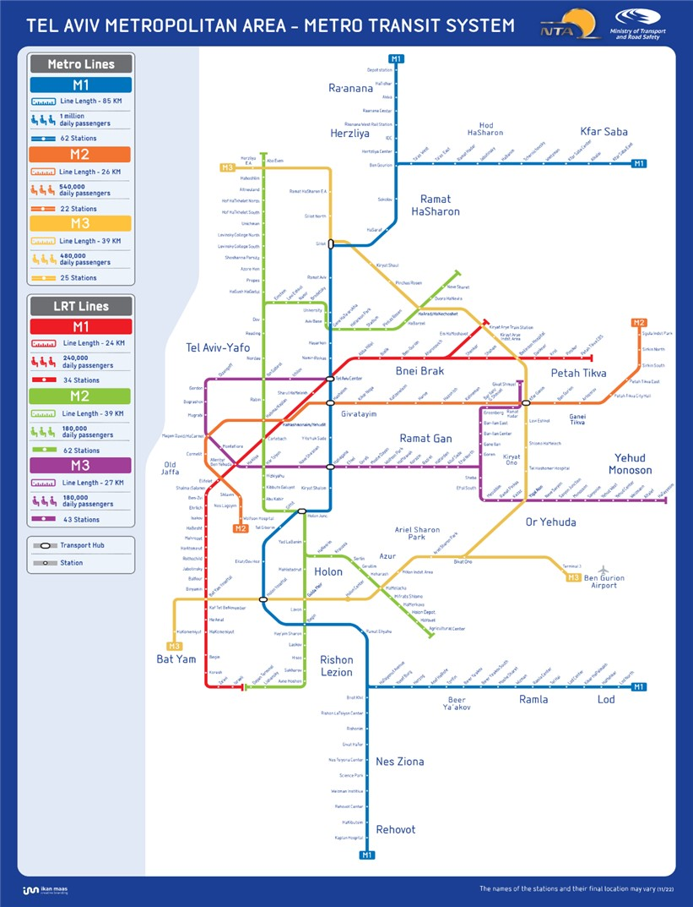

SPECIFICATIONS FOR REQUESTED SOLUTIONS
Responses to this RFI are welcome from big Suppliers / Consortia /Start-ups (the "Participants") which have proven experience with CBTC system in similar projects, and/or are developing innovative solutions for the next generation of metro rail signaling systems which satisfies the criteria summarized below.
In the Tel Aviv Metro Network, each metro line shall have a Signaling & Train Control (S&TC) system to control train movement in automatic mode, control train routes, and provide the operations staff with the tools to supervise and control the operation of the line from the OCC.
The S&TC system for a metro line shall provide the following main functions:
- A communication-Based Train Control (CBTC) system, which includes
  - Automatic Train Supervision (ATS) system
  - Data Communication System (DCS)
  - Signalling Maintenance Management system (SMMS)
  - Timetable Generator (TTG)
  - Record event Player (REP)
- Interlocking (IXL) system
- Secondary Train Detection (STD) system
- Metro Railway Schedule System (MRSS)
This system should satisfy the following criteria:
- All three Metro lines will be equipped with CBTC based GoA4 signaling System.
- Regardless of the track configuration at terminal stations and the number of available trains, the S&TC system shall support a 70 second technical headway and a 85 second operating headway, without affecting the commercial speeds.
- The bi-directional wireless communication network for the S&TC system shall be based on Wi-Fi or Ultra-Wideband (UWB) technologies in the frequency bandwidth of 5.9 GHz, matching the standards IEEE 802.11p or IEEE 802.15.4 respectively.
- The S&TC system shall use the additional wireless communication channel LTE or 5G when the Wi-Fi or UWB-based wireless communication network fails in order to maintain the communication between the wayside and onboard S&TC systems.
- In case LTE or 5G communication system is used also for other IT systems, like CCTV or PIDS onboard the trains, the S&TC system shall provide all the security devices to filter the network communication, according to the standard EN 50159.
- The S&TC System shall include, among several interfaces, the functional interface specifications with the Platform Screen Doors system.
- The onboard S&TC System shall fulfil the requisites of the standard EN 50155.
- The S&TC System shall follow a system lifecycle process that complies with the standards EN 50129 and EN 50128, and demonstrate the reliability, availability, maintainability, and safety complying with the standard EN 50126-1.
- The S&TC System shall comply with the requirements in the Israeli standards IS-5350 & IS-5435 and comply with the safety requirements stated in the international standard IEC-62267, unless the requirements are met by corresponding CENELEC standards.
- The S&TC subsystems shall comply with the following SIL requirements:
Sr. No | Subsystem / Function | SIL level
1 | CBTC system | SIL-4
2 | Interlocking system | SIL-4
3 | Secondary detection system | SIL-4
4 | ATS | SIL-3

A LIST OF DATES FOR THIS RFI
- Date of publication of the RFI – April 4, 2024.
- The deadline for submission of clarification questions by the Participants - May 15, 2024, at 13:00.
- The deadline for submission of responses to the RFI - June 17, 2024, at 13:00.

COMMERCIAL CONFIDENTIALITY AND WAIVER OF CLAIMS
- NTA may use any information it receives during or in connection with the RFI from a Participant or any third party (the "Information") for any purpose it deems fit, including for preparing specifications, tenders or any other documents. In addition, NTA may transfer any such Information to any of its consultants or any person on its behalf. The supplier of the Information waives all claims and demands of any kind against NTA in connection with NTA's abovementioned rights, including (but not limited to) copyrights, commercial confidentiality, privacy, etc.
- Without derogating from the above, the Participants may mark, in a clear, complete and legible manner, Information contained in the Response which is considered commercially sensitive or of a confidential nature. To the extent permitted by applicable laws, and at its sole discretion, NTA shall consider refraining from disclosing such Information (if so requested).
- The Participant declares and confirms that the provided Information is free from any violations of third-party rights, including (but not limited to) copyrights, commercial confidentiality, privacy etc. The Participant shall bear full and exclusive responsibility for any claims or demands arising from such third-party rights violations subsequent to this RFI, and all related expenses will be solely borne by the Participant.

INSTRUCTIONS REGARDING THE SUBMISSION OF THE RESPONSE TO THE RFI
- Participants are free to choose the questions to respond to, based on their expertise and experience, it is not mandatory to respond to all of the questions.
- The Participants are requested to fill-in all the information on Annex A. Each question should be addressed separately.
- It is recommended to attach supporting information in a visual format such as presentations, videos, photos, brochures, etc.
- The response to the RFI shall be submitted in English. Appendices and technical specifications can be attached unlimited in scope.
- The response to the RFI must be submitted in a digital copy by the deadline for submitting responses, as specified in section 4 above, via email: Tender1@nta.co.il. The email’s subject line will state: "A response to RFI to receive relevant information about technological and design innovative solutions for CBTC-based signaling system”.
- NTA may postpone the response submission deadline at its sole discretion. A notice to that effect shall be posted on NTA's website. The notice shall specify the new response submission date.

EXAMINATION OF THE RESPONSE
- NTA reserves the right, at its sole discretion, to contact, as necessary, all or some of the Participants with requests for information and clarifications, for presentations and demonstrations, for visits to the Participants' sites and the sites of their clients, etc.
- As part of the response examination process, NTA reserves the right to invite any Participant to present the solution proposed by it to a professional team on its behalf at a location and at a time determined by NTA.
- As part of the response examination process, NTA reserves the right, at its sole discretion, to invite all or some of the Participants to launch a pilot project.

QUESTIONS AND CLARIFICATION REQUESTS
- Clarification questions regarding this RFI must be submitted only in writing, via e-mail to NTA's contact person, as specified in section 10 below. The questions must be submitted no later than the deadline for clarification questions as detailed in section 4 above.
- The Participant must verify that its questions were received by the contact person, as specified in section 10 below, by phone.
- NTA reserves the right to conduct one or more rounds of clarification questions at its sole discretion.
- The clarification questions will be submitted in English, in the following format:
Number of the section in the RFI | Question
- Answers to the clarification questions will be posted on NTA's website.
- It is underlined that the clarification answers will be worded in a way that does not reveal the identity of the inquirer.

RESERVATIONS AND NTA'S DISCRETIONS
- NTA may publish a new Request for Information, an invitation to pre-qualify, tender proceedings and/or any other proceedings with respect to the Project or any part thereof and/or with respect to any other project whatsoever, in any manner which it will deem appropriate. Without derogating from the above, NTA may pursue any engagement based on the information submitted in this RFI, whether through the conduct of a bid or a tender, or without conducting such proceedings, as NTA deems fit.
- NTA may request additional information (in writing or otherwise) as it deems necessary, request to visit sites or facilities constructed or operated by the Participant, or carry out professional inquiries regarding any Participant (including by way of contacting third parties(.
- The Participants shall not be entitled to any payment for the information provided by them pursuant to this RFI. All expenses incurred by a Participant or anyone on its behalf shall be borne solely by the Participant. Participants shall not be entitled to any reimbursement or compensation for expenses in connection to their participation in this RFI.
- NTA shall not be responsible or liable towards a Participant or anyone on its behalf in connection with this RFI, including in connection with information provided by or to NTA pursuant to or in connection with this RFI.
- NTA may amend, withdraw or cancel this RFI, at any time and without providing reasons or justifications for doing so.
- This RFI is subject to the law of the State of Israel, including the Mandatory Tenders Regulations, 5753-1993 and the obligation to disclose information in accordance with Section 14A thereof.

CONTACT PERSON ON BEHALF OF NTA
The contact person on behalf of NTA regarding this RFI is Moran hen, email :moranhe@nta.co.il.

ANNEX A - RESPONSE TO THE RFI
General:
- This Appendix must be digital.
- Additional information should be attached to the relevant Appendix.
- It is recommended to attach supporting information in a visual format such as presentations, videos, photos, brochures etc.
- Information about the Participant:
Supporting documents for questions 1-2 will be attached in a separate file captioned "Appendix 1".
- General details regarding the company or individual submitting the response (the "Participant"):
Participant's name:
(Name of company or individual submitting the response)
Classification of the Participant: (corporation, association, authorized dealer, independent consultant, etc.)
I.D number/Company Registration Number:
Contact Person:
(Full name, position)
Address:
Phone no.:
E-mail:
Should NTA decide at its sole discretion to launch a pilot, would the Participant be interested in participating?
- Details about the Participant's knowledge and area of expertise and the relevance of the Participant’s experience to the Project, if any.
- Information about the proposed “Solution/s”:
* Documents supporting answers to questions 3-13, complying where possible with the “Specifications” listed in section 4, will be attached in a separate file captioned "Appendix 2".
P.N. Responses are welcome from big Suppliers/Consortia/startups that have experiences with CBTC-based signaling systems implemented in similar Metro/Transportation projects embracing all main project’s lifecycle, comply with the “Specifications” specified in section 4 and/or are developing innovative solutions for the next generation of metro rail signaling systems.
- Are you working on UWB-based CBTC signaling systems? If yes, please provide a general description of your UWB-based CBTC system.
- Requirements for demonstration of viability for UWB-based CBTC system
- Maturity of technology: Is this technology mature enough to be implemented in the complex megaprojects in Tel Aviv?
- Benefits: What benefits does your system bring with respect to traditional CBTC systems?
- Performance: How do you measure the performance of your system?
- Testing: How would you test your system? Please describe the pilot that could be implemented to test the proposed solution's reliability.
- Adaptability and Integrability: How could a UWB-based S&TC system be used for efficient interoperability among the metro lines? How does it integrate with maintenance vehicles?
Additional remarks: What could be potential disadvantages in using this technology for the Tel Aviv Metro?
- Readiness and Market Constraints for UWB-based CBTC system
Kindly provide details and your opinion and perception of market constraints which should be taken into account and managed.
- Are you working on a unified protocol for CBTC solutions? What is the challenge to implement a unified protocol (where components from different suppliers work together to form the CBTC system) for the Tel Aviv metro for interoperable CBTC?
- How does your signaling solution support optimizing train operations to enhance passenger capacity? What other O&M enhancement does your signaling system provide?
- Is your technology mature enough to be implemented in the complex megaprojects of Tel Aviv? What are the major constraints of the “Solution/s” in the actual scenario? What do you expect for the future years?
- How does/do your “Solution/s” work with third-party systems? How well can it/they adapt to the wider objectives of the program? How can you ensure that even with different designers (for instance with crowd monitoring, security and communication systems etc.) your system will work seamlessly?
- How do you measure the performance (i.e., KPIs) of your system? Please elaborate for each solutions above.
- Based on experience in similar Metro, Rail and/or LRT projects, please advise which potential procurement strategy can be compatible and best suitable for the implementation of the project.
- Please describe the means used by any proposed S&TC system that aids recovery of a non-communicating train (or failed communications network).
- In addition to using secondary train protection, please describe solution(s) where alternatives to secondary train detection are used.
C. Information regarding maintenance of the proposed Solution:
* Documents supporting answers to question 14, will be attached in a separate file captioned "Appendix 3".
- For each unique solution proposed: what is the required maintenance routine? How is it performed? What faults may appear in the Solution over time, including disabling faults? What is the treatment method?
F. Information regarding the Solution's privacy protection and information security measures:
* Documents supporting answers to question 15, will be attached in a separate file captioned "Appendix 4".
- What measures exist in the Solution to guarantee the protection of privacy and the security of information?
G. Additional relevant information about the proposed technological Solution/s or other solutions/functionalities relevant to the scope of the project.
* Documents supporting further information will be attached in a separate file captioned "Appendix 5".
RESPONSE BY: [NAME, TITLE, COMPANY] |  | DATE:
ATTACHMENTS:

